**Diversity and Distribution of Rift Valley Fever and Malaria Transmitting Mosquitoes in Baringo County, Kenya**

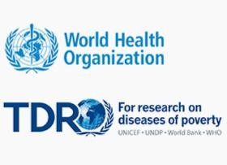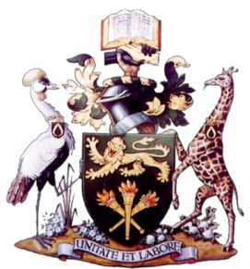

*“Population health vulnerabilities to vector-borne diseases: increasing resilience*

**UoN JOOUST**

*under climate change conditions in Africa”.*

**IM. Ondiba1, FA. Oyieke1, GO. Ong’amo1, DA. Kobia1, E. Kipruto2, C. Loye1, AO. Oluoch2, IK. Nyamongo1 and BB.A. Estambale2**

# Abstract

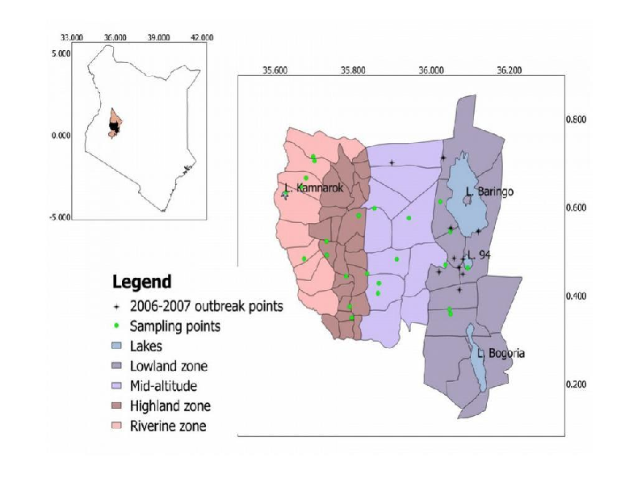

**Study Area Country:** Kenya

**Study Period:** June 2014 to June 2015

**Figure1:** Map of Study area showing sampled points in different zones

**Background**: Mosquitoes are responsible for transmission of human and animal vector borne diseases (VBDs) across the world particularly to vulnerable communities in the tropics. Malaria and RVF are among the VBDs which are transmitted by mosquitoes. Whereas malaria occurs seasonally, RVF is sporadic. Distributions of these vectors vary with altitude, an aspect that is likely to be affected by climate change. However, there is limited information on the diversity and distribution of these vectors in Baringo; information necessary for targeted vector control. It is on this background that this study was undertaken.

**Methodology**: This study assessed diversity and distribution of mosquito vectors of Rift Valley Fever (RVF) and malaria in Baringo County, Kenya. It involved sampling and identification of immature mosquitoes from different aquatic habitats.

**Results**: Important malaria vectors identified included *An. gambiae, An. funestus* and *An. pharoensis.* Secondary RVF vectors identified included *Cx. quinquefasciatus* and *Cx. pipiens* while *Aedes* species collected at lowlands and highlands are arbovirus vectors.

**Conclusions**: Although vectors were present in all study sites, their numbers varied among different zones indicating different levels of disease risk for the communities at different altitudinal zones.

# Aim and Objectives Methodology

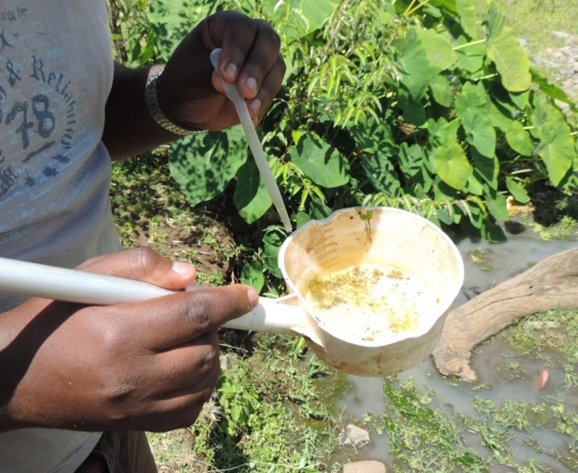

The study was undertaken in four zones based on elevation within Baringo County, Kenya. Fig.1. It involved sampling of immature mosquitoes

in aquatic habitats using a standard dipper and pipette. Fig.2 (a). The collected specimens were morphologically identified to species level under a dissecting microscope using taxonomic keys Fig. 2 (b). Principle Component Analysis (PCA) was used to estimate species diversity for each zone and Shannon diversity t-test to compare zones.

**Figure: 2 (a); Larval Collection**

**Figure: 2 (b); Mosquito Identification**

To determine the diversity of Mosquito vectors of Rift Valley Fever and Malaria in Baringo County of Kenya

To establish the distribution of Vectors Rift Valley Fever and Malaria along altitudinal transect in Baringo County, Kenya

# Results Conclusions



A total of 2691 immature mosquitoes belonging to 13 species were collected from all sites across the four zones. Of the 13 species,

three of the anophelines; *Anopheles gambiae* s.l. , *Anopheles funestus* and *Anopheles pharoensis* are known vectors of malaria, while three *Aedes* species; *Aedes aegypti* , *Aedes taylori* and *Aedes africanus* are implicated in the transmission of arboviruses. *Culex quinquefasciatus*, which was the most abundant species (35.5%), has also been incriminated in the transmission of RVF. Lowland and riverine were ecologically similar in terms of species composition (**Fig.3)** however pairwise comparison between zones showed no statistical difference between highland and the two zones (**Table 1).** Midland zone was different from all other zones **(Table 1)** and had the largest proportion of *An. gambiae* (**Fig.3).** Highland had the largest number (5) of dominant species.

**Table 1:** Pairwise comparison of species

diversity between the zones using Shannon t-test

Species

Samples

*Cx.annulioris*

**Midland**

*An.gambiae*

*Ae.taylori*

*Cx.tigripes* **Highland**

*Ae.africanus Cx.poicilipes*

*An.coustani*

*Cx.dutoni*

*Cx.quinquefasciatus*

**Riverine**

*An.pharoensis*

*Cx.pipiens*

**Lowland**

*An.funestus*

*Ae.aegypti*

-1.0

PCA1

1.0

**Figure 3: species diversity and**

**distribution between zones**

There are more than 2 vector species for RVF and malaria in Baringo County.

The presence of Anopheline species in all study zones indicates risk of malaria more so at lowlands and midlands of the County.

The presence of *Aedes* and several *Culex* species previously reported as vectors indicate the potential for virus transmission in case of RVF outbreak.

# Acknowledgements

1.0

PCA2

|  |  |  |  |
| --- | --- | --- | --- |
|  | Riverine | Lowland | Midland |
| Lowland | t85.31=1.94; p=0.055 |  |  |
| Midland | t74.08=3.87; p=0.000 | t1685.5=4.31; p=0.012 |  |
| Highland | t98.9=1.12; p=0.267 | t1712.3=1.39; p=0.166 | *t*1273.4=5.14; p=0.002 |

We would like to acknowledge the following people and institutions:

The project field staff for their role in data collection

International Development Research Centre of Canada (IDRC)and WHO’s Special Programme for Research and Training in Tropical Diseases (TDR) tor funding this study

The University of Nairobi and Jaramogi Oginga Odinga University of Science and Technology

## Contact Author: [bellamoraa@yahoo.co.uk](mailto:bellamoraa@yahoo.co.uk)

**Collaborating Institutions**

**1**University of Nairobi, **2**Jaramogi Oginga Odinga University of Science and Technology

*This material is based upon work supported by NASA through contract NNL11AA00B and cooperative agreement NNX14AB60A.*

**Project Partners**

**Baringo County Kenya:** Department of Health, Division of vector-borne Diseases Laboratory (Marigat) and the Community Members

-1.0